# Informações do estudo

Referência: Keblouti - coated insert

Grandeza: Força

Tipo: Fx

Material: AISI 52100

Ferramenta: GC 1525 coated insert

Número de experimentos: 27

Observações:  
Universal lathe SN 40C type  
Workpiece: round bars66 mm of diameter and 380 mm cutting length.  
Dynamometer: KISTLER Type 9257A  
Roughnessmeter: Surftest 201 Mitutoyo

# Unidades

Velocidade: m/min

Avanço: mm/rev

Profundidade de corte: mm

Força: N

# Dados de teste

|  |  |  |  |
| --- | --- | --- | --- |
| Força | n | f | a |
| 46.11 | 200.0 | 0.12 | 0.15 |
| 110.81 | 200.0 | 0.16 | 0.45 |
| 69.13 | 200.0 | 0.08 | 0.45 |
| 72.53 | 250.0 | 0.12 | 0.45 |
| 48.27 | 200.0 | 0.16 | 0.15 |
| 54.67 | 200.0 | 0.12 | 0.3 |

# Dados de treino

|  |  |  |  |
| --- | --- | --- | --- |
| Força | n | f | a |
| 102.24 | 150.0 | 0.12 | 0.45 |
| 65.34 | 150.0 | 0.12 | 0.3 |
| 76.83 | 150.0 | 0.08 | 0.45 |
| 83.28 | 150.0 | 0.16 | 0.3 |
| 71.33 | 250.0 | 0.16 | 0.3 |
| 43.88 | 250.0 | 0.12 | 0.15 |
| 53.82 | 200.0 | 0.08 | 0.3 |
| 127.96 | 150.0 | 0.16 | 0.45 |
| 123.36 | 250.0 | 0.16 | 0.45 |
| 52.12 | 150.0 | 0.08 | 0.3 |
| 48.78 | 150.0 | 0.08 | 0.15 |
| 47.52 | 250.0 | 0.08 | 0.15 |
| 74.66 | 250.0 | 0.08 | 0.3 |
| 53.14 | 150.0 | 0.12 | 0.15 |
| 50.35 | 250.0 | 0.16 | 0.15 |
| 89.91 | 200.0 | 0.12 | 0.45 |
| 46.5 | 250.0 | 0.12 | 0.3 |
| 43.05 | 200.0 | 0.08 | 0.15 |
| 89.87 | 250.0 | 0.08 | 0.45 |
| 70.34 | 150.0 | 0.16 | 0.15 |
| 62.89 | 200.0 | 0.16 | 0.3 |

# RN

Número de neurônios: 25

Taxa de aprendizado: 1.000000e-01

Número de épocas: 562

2° camada: True

Função de ativação: relu

# Erros

**Dados de teste**

* Erro relativo médio: 13.09
* Coeficiente de correlação: 0.95
* Coeficiente de determinação: 0.91
* MSE: 135.8
* RMSE: 11.65

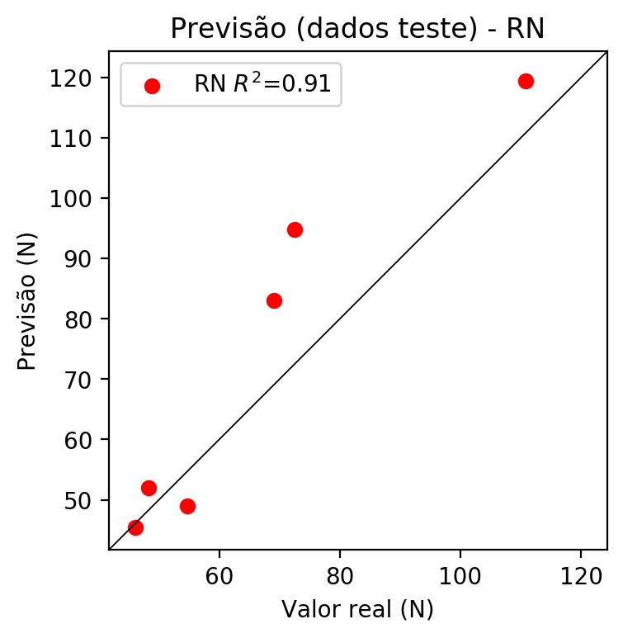

**Dados de treino**

* Erro relativo médio: 0.0
* Coeficiente de correlação: 1.0
* Coeficiente de determinação: 1.0
* MSE: 0.0
* RMSE: 0.0

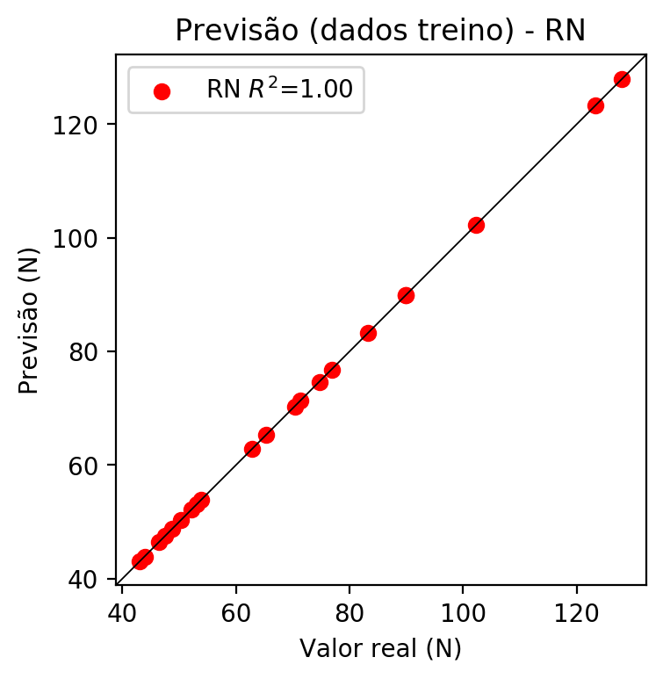

# Pesos

Pesos - camada oculta 1

[[ 0.28404662 0.01439297 0.18382296 -0.24803509 0.2576329 0.23884402  
 0.69608855 -0.89381 -0.46266198 0.0050341 -0.6836705 -0.03387878  
 -0.32243416 -0.4188212 0.09236204 0.02065658 -0.5150713 0.05429888  
 -0.5319198 0.1838373 0.13905984 -0.18603566 0.77844477 -0.7498327  
 -0.5221491 ]  
 [ 0.3715011 0.05058728 -0.2677808 -0.34045357 -0.16080564 -0.12141541  
 -1.0640483 0.1640299 -0.6954743 -0.30996287 0.19289926 0.26194182  
 0.36629954 0.35670793 0.40654123 0.5770169 -0.24970299 0.3784721  
 0.31259617 0.5008956 -0.70779616 -0.29289836 0.6379426 -0.03189132  
 0.78479016]  
 [ 1.1772797 0.56422645 -0.63883644 -0.43611097 -0.6845458 0.11165162  
 0.55671996 -0.25479952 -0.02998395 -0.08073763 0.978691 0.0472737  
 -0.1529053 0.5543364 0.7292674 -0.2538441 0.05385547 0.717968  
 0.75429684 0.4462667 0.22798449 0.56341255 0.35682985 0.5944535  
 0.6688559 ]]

Bias - camada oculta

[-0.42033285 -0.6212716 -0.8075141 -0.2873957 0.21751982 -1.0723332  
 -0.9951155 -0.37087077 -0.3602655 -0.7862335 -0.53749543 -0.4466292  
 -0.2635035 -0.5236621 -0.4667547 -0.14894304 -1.2882667 -0.23895177  
 -0.56856585 -0.4871392 -0.35041636 -0.64875764 -0.6440669 -0.9982612  
 -0.08220994]

Pesos - camada oculta 2

[[ 2.13864088e-01 7.82575309e-01 -6.11112416e-01 8.38504374e-01  
 1.06922436e+00 -1.75748140e-01 -3.71048361e-01 4.33766842e-01  
 -4.64280963e-01 -1.18538439e+00 -5.97834706e-01 2.28108406e-01  
 -1.12970281e+00 -4.45485920e-01 -3.95170093e-01 -4.69005644e-01  
 -1.18245947e+00 -7.01815069e-01 -1.10183120e+00 1.17217645e-01  
 2.37332404e-01 -3.58929127e-01 -6.67816877e-01 8.36575866e-01  
 1.10795236e+00]  
 [ 1.69747919e-02 3.86920869e-01 -4.80958939e-01 1.83400944e-01  
 3.20130847e-02 -7.38092422e-01 -9.89044011e-01 -3.07842523e-01  
 -4.88558024e-01 2.35013098e-01 4.16022316e-02 3.50096852e-01  
 7.55136982e-02 -6.25777423e-01 -5.69352269e-01 -5.46719909e-01  
 3.05074215e-01 -3.09628338e-01 -4.36476320e-01 4.56595391e-01  
 4.27790374e-01 5.93543053e-01 -9.83533144e-01 4.30463225e-01  
 -5.63496232e-01]  
 [ 2.01892719e-01 -5.84615096e-02 8.18475112e-02 -6.18232310e-01  
 -2.52019733e-01 1.61911994e-01 8.20870325e-02 -2.07086623e-01  
 -1.32748455e-01 2.57887661e-01 1.43480986e-01 -3.28829944e-01  
 -1.61057979e-01 1.94470771e-02 -8.77693743e-02 -5.37063062e-01  
 3.35323155e-01 -4.85502273e-01 -9.13555682e-01 -9.55329537e-01  
 -6.87194318e-02 -5.63412666e-01 -8.56751502e-01 -9.46744084e-01  
 -8.61078143e-01]  
 [-2.68185407e-01 -6.03958219e-02 -2.05996901e-01 -1.22851104e-01  
 -2.58689284e-01 -1.58439353e-01 -6.94422245e-01 -6.82372093e-01  
 -2.50019997e-01 -2.01885942e-02 1.69875816e-01 -1.03847504e-01  
 -4.32700545e-01 -4.68980461e-01 1.78218514e-01 -5.93659580e-01  
 -2.05145683e-02 -9.53797638e-01 -5.10797977e-01 -7.02210009e-01  
 -1.80114418e-01 -9.35237825e-01 -6.32991850e-01 2.78109685e-03  
 -1.09297431e+00]  
 [-1.69815391e-01 -7.04007983e-01 4.25590336e-01 -3.24574798e-01  
 -2.29813486e-01 -6.28185928e-01 -3.92393053e-01 -5.80929041e-01  
 -5.38190566e-02 -3.85327935e-01 1.41208306e-01 -9.94881690e-01  
 -3.08472008e-01 1.28517479e-01 7.71442056e-02 2.60925502e-01  
 -5.84376216e-01 6.60704076e-02 -3.56670976e-01 -8.05988848e-01  
 -5.96287787e-01 -8.35325837e-01 -4.05353576e-01 -9.51765537e-01  
 3.21027520e-03]  
 [ 8.98255169e-01 1.10462928e+00 -1.12502322e-01 3.28896195e-01  
 2.91450351e-01 -9.57902670e-02 -2.60252029e-01 1.52821854e-01  
 -4.06794772e-02 8.93917978e-01 7.11221024e-02 3.40905130e-01  
 -4.66568112e-01 -5.58674157e-01 -5.11544704e-01 -7.07336783e-01  
 2.91578770e-01 -5.83572686e-01 -7.27384806e-01 -6.01401567e-01  
 1.93260312e-01 -2.93541491e-01 -4.37010318e-01 -8.90383244e-01  
 -4.60533231e-01]  
 [-9.58236232e-02 4.51678813e-01 -5.01239598e-01 4.14486051e-01  
 1.12932515e+00 -4.28613216e-01 6.13636225e-02 3.45813811e-01  
 -6.65790439e-02 -6.31388724e-01 -7.40517080e-01 -4.68438387e-01  
 -8.55911016e-01 -2.95980006e-01 -9.52341616e-01 -4.93462145e-01  
 -3.77856672e-01 4.25079465e-01 -9.80568752e-02 -7.37850785e-01  
 -7.36617863e-01 -4.02251571e-01 -1.11706316e+00 -1.36405617e-01  
 5.25151253e-01]  
 [-2.57420719e-01 -2.09583476e-01 2.48403803e-01 -9.30801332e-02  
 3.41833472e-01 4.73663360e-01 1.18438266e-01 2.36374825e-01  
 -2.29231939e-02 -8.88052464e-01 -1.17415833e+00 1.12101063e-01  
 -5.51923811e-01 -2.92656291e-02 -1.78185189e+00 1.36502579e-01  
 -9.10313606e-01 4.63998258e-01 6.41334832e-01 -4.51498538e-01  
 -5.04102468e-01 -3.63401115e-01 -4.44021881e-01 -7.38994360e-01  
 5.35299659e-01]  
 [-3.85880232e-01 -9.48854625e-01 4.79987770e-01 2.61895563e-02  
 -2.84969687e-01 -2.56721437e-01 -2.02454373e-01 -8.64015996e-01  
 -3.36142406e-02 -3.53113949e-01 -2.99788862e-01 -8.42327476e-01  
 -8.60445857e-01 2.08231524e-01 -1.36829510e-01 2.33817138e-02  
 -4.51186717e-01 7.04834402e-01 3.59762937e-01 -4.65709716e-01  
 -4.14438158e-01 -4.61419940e-01 2.67543904e-02 -4.06765610e-01  
 5.99966764e-01]  
 [-7.77325571e-01 1.37922876e-02 -9.35724601e-02 2.78764844e-01  
 2.10939273e-01 -7.16935635e-01 -4.35256332e-01 -1.89087585e-01  
 -4.80682343e-01 -3.28378558e-01 1.59869716e-01 -4.59309429e-01  
 -7.24845111e-01 1.93241000e-01 -3.10810238e-01 -7.83330761e-03  
 -6.70935333e-01 6.67879522e-01 8.57621506e-02 -4.73339796e-01  
 -3.18515122e-01 -5.60153246e-01 -1.40852451e-01 -5.90136409e-01  
 6.23533010e-01]  
 [-7.51930624e-02 -3.19736063e-01 5.68529606e-01 -5.98173678e-01  
 5.13011873e-01 4.11998510e-01 4.06459093e-01 -1.98428035e-01  
 2.46090800e-01 -7.89088309e-01 -4.40430880e-01 2.91316032e-01  
 -9.85908151e-01 -5.40009499e-01 -7.83056319e-01 -4.30847138e-01  
 -5.56586623e-01 -7.60445654e-01 -9.03918803e-01 -6.72861457e-01  
 -5.82970791e-02 -5.27927518e-01 -9.37353075e-01 -1.16664863e+00  
 -9.56680954e-01]  
 [-6.00931585e-01 1.33960694e-02 -1.28752127e-01 4.05945666e-02  
 2.91805238e-01 -4.54910696e-01 -7.35663772e-02 -7.66539276e-01  
 -3.41260910e-01 -5.00343919e-01 4.74242210e-01 -3.10791463e-01  
 -5.41836381e-01 -1.33748218e-01 -2.38952134e-02 -1.80196464e-01  
 -3.30016941e-01 -8.52697611e-01 2.10813656e-01 -3.62376690e-01  
 -2.26510882e-01 -6.73628092e-01 -5.60147643e-01 -6.94045126e-01  
 4.88675624e-01]  
 [-8.09070885e-01 -6.34167790e-01 -3.43433321e-01 -1.97899882e-02  
 1.02948532e-01 -2.67778903e-01 -3.67022246e-01 -4.15535629e-01  
 6.05494641e-02 -5.90366185e-01 2.49869421e-01 -9.05918121e-01  
 -4.43066359e-01 -1.31722331e-01 1.12907648e-01 -7.15721175e-02  
 -3.07655245e-01 -4.91410941e-01 -1.91832379e-01 -4.99175370e-01  
 -6.63779974e-01 -7.79055357e-01 -2.58465290e-01 -7.88333595e-01  
 -5.07046044e-01]  
 [-5.88211954e-01 -1.53962642e-01 8.58503953e-02 -2.55245060e-01  
 3.77370894e-01 8.21624100e-02 3.70402813e-01 -2.48335138e-01  
 -1.67846426e-01 -7.75316715e-01 -6.79595828e-01 -1.73981726e-01  
 -6.63303375e-01 -1.50549322e-01 -1.08050096e+00 -1.35545060e-01  
 -1.14958704e+00 6.99631453e-01 5.24382591e-01 -5.64755380e-01  
 1.93541870e-02 -4.95075345e-01 -7.88010955e-01 -1.04755700e+00  
 2.11907536e-01]  
 [ 1.35773614e-01 -2.32138574e-01 -7.79034793e-02 -5.03909171e-01  
 2.92541295e-01 6.23812899e-02 4.65683118e-02 7.00526685e-02  
 3.06125373e-01 4.15285677e-02 -8.70905742e-02 -4.49359566e-02  
 -5.90543270e-01 -5.74577034e-01 -4.56186831e-01 -4.22494531e-01  
 2.86630124e-01 -4.93040264e-01 -2.98455179e-01 -1.08458734e+00  
 3.67091805e-01 -7.22600400e-01 -2.93122828e-01 -2.11605474e-01  
 -5.83895922e-01]  
 [-5.03060520e-01 -4.72683340e-01 -4.88186747e-01 -4.55845892e-01  
 2.04670072e-01 -1.81147635e-01 -1.06245637e-01 -2.37807795e-01  
 -4.26653922e-01 -7.98784077e-01 5.21706827e-02 -3.83661121e-01  
 -2.31299117e-01 4.33729291e-01 2.27374241e-01 -6.29504859e-01  
 -5.19488752e-01 2.59025514e-01 1.67387664e-01 -9.50058401e-01  
 -7.19407260e-01 -4.81411099e-01 4.87325341e-02 -7.86366582e-01  
 -1.37370510e-03]  
 [-9.00953412e-01 -4.32597071e-01 -1.23375870e-01 -1.86338231e-01  
 1.19880922e-01 -5.42680323e-01 -5.16671240e-01 -3.98110807e-01  
 -6.19360991e-02 -8.51655528e-02 -6.86824769e-02 -5.74388802e-01  
 -5.49914241e-01 1.47047907e-01 -2.36692559e-02 -5.40825129e-01  
 -4.58191812e-01 -8.91494215e-01 -1.89278841e-01 -9.97934401e-01  
 -5.13261676e-01 -7.01553702e-01 -7.22824633e-01 -1.85004666e-01  
 -4.00866598e-01]  
 [ 1.50794968e-01 7.69899506e-03 -6.90345407e-01 6.16907589e-02  
 5.49026489e-01 -8.16217661e-01 -8.64989161e-02 3.13089639e-01  
 -7.65198648e-01 -1.83999136e-01 1.67251319e-01 1.88345596e-01  
 1.05278650e-02 -4.68880266e-01 -4.87058878e-01 -6.22288883e-01  
 -2.91625828e-01 -4.15798455e-01 -8.45374048e-01 4.68978696e-02  
 3.60389620e-01 3.20252120e-01 -5.18861830e-01 1.09653652e-01  
 -1.04265702e+00]  
 [-3.78984749e-01 -4.14285660e-01 -2.47078285e-01 -8.64271641e-01  
 3.26678962e-01 -2.29111403e-01 2.66437799e-01 5.89846633e-02  
 -5.19449115e-01 -9.61668849e-01 4.96124253e-02 1.48423836e-01  
 -2.96753407e-01 -3.80556077e-01 -3.78239393e-01 -3.76347572e-01  
 -6.42192960e-01 -5.33081770e-01 -1.11364031e+00 -5.61536729e-01  
 8.98656715e-03 -6.25875533e-01 -6.41229033e-01 -1.15462112e+00  
 1.17927812e-01]  
 [-6.97264194e-01 -8.92758667e-02 -4.02509809e-01 1.06719971e-01  
 3.38165671e-01 -7.03453422e-01 -4.55766618e-01 -2.95230389e-01  
 -2.17420056e-01 -4.11604881e-01 2.90370613e-01 -3.43939960e-01  
 -6.20814860e-01 -4.00052480e-02 -1.72032967e-01 -2.56376058e-01  
 -1.09789228e+00 -6.19407952e-01 2.89904959e-02 -3.10224742e-01  
 -2.39143029e-01 -6.70452893e-01 -3.54343235e-01 6.10227704e-01  
 -1.39164135e-01]  
 [ 1.03494599e-01 8.30451995e-02 -2.86252797e-01 1.03278622e-01  
 3.99279773e-01 -2.16813430e-01 -1.52689874e-01 -5.21619245e-02  
 -1.37501210e-02 -6.14864469e-01 8.60467032e-02 -8.73513341e-01  
 -7.85471976e-01 5.53170703e-02 -4.18223366e-02 1.92894961e-03  
 -9.30893838e-01 -5.82153618e-01 -5.98300278e-01 -9.47245598e-01  
 -5.63945055e-01 -6.55847490e-01 -4.99194652e-01 -4.10686076e-01  
 -2.05016211e-01]  
 [-1.73472434e-01 2.04436168e-01 1.05284154e-01 5.59479952e-01  
 5.42714059e-01 -7.95790136e-01 -4.23629999e-01 1.41754774e-02  
 -5.31409606e-02 -2.43410945e-01 9.34160128e-02 -5.63009918e-01  
 -8.24232459e-01 -1.49593994e-01 -1.19675331e-01 -2.38014720e-02  
 -7.34724462e-01 -4.88635600e-01 -6.92977190e-01 -3.33035767e-01  
 -5.07842064e-01 -3.01752627e-01 -2.49064863e-01 -1.99847832e-01  
 4.40256670e-02]  
 [-7.03723550e-01 1.97173670e-01 7.12808013e-01 -4.02027994e-01  
 6.49803579e-01 3.04710120e-01 -2.45422404e-02 -2.90732473e-01  
 2.23596126e-01 -9.44885671e-01 -2.66005009e-01 -6.62506402e-01  
 -3.92770767e-01 1.77124485e-01 -5.40876508e-01 3.41228694e-01  
 -4.23681617e-01 6.53334975e-01 3.40746433e-01 -3.95485103e-01  
 -4.59526986e-01 -8.44958425e-01 6.04453444e-01 -2.72755802e-01  
 3.01075667e-01]  
 [-4.31451321e-01 -2.39879675e-02 -9.37089920e-02 -1.53039694e-01  
 2.47227013e-01 -3.66146892e-01 -6.15714133e-01 -3.65312964e-01  
 -1.02504604e-01 -4.35967326e-01 2.82497890e-02 -4.40169610e-02  
 -5.98297775e-01 -8.46568048e-02 -6.42798692e-02 -6.20007873e-01  
 -4.76424009e-01 -5.51445067e-01 -2.47956738e-01 -4.64077771e-01  
 -1.22326493e-01 -2.54375041e-01 -5.34700632e-01 -2.83709615e-01  
 5.44334836e-02]  
 [ 2.49614358e-01 -2.45479718e-01 -9.69428122e-01 -3.26971680e-01  
 6.86627090e-01 -1.02470338e+00 -4.61994946e-01 2.73522168e-01  
 -5.78372538e-01 -1.76058784e-01 3.21432650e-02 1.88862607e-01  
 -5.06440699e-01 -2.29730308e-01 -7.07768857e-01 -9.10451591e-01  
 -1.41537100e-01 -7.65757740e-01 -4.56228256e-01 5.37220426e-02  
 6.85239553e-01 4.65266347e-01 -8.44501495e-01 4.79254544e-01  
 -7.69935489e-01]]

Bias - camada oculta 2

[-0.45234892 -0.2421821 0.4409757 -0.28553602 -0.06487852 -0.18439738  
 -0.1514063 -0.43088758 -0.04287148 -1.0023758 0.6322591 -0.3086872  
 -0.8636216 -0.12184003 0.14842118 -0.1022843 -1.0571834 -0.64548063  
 -0.63802564 -0.6478286 -0.43759072 -0.60054326 -0.82131135 -0.39586937  
 -0.50147986]

Pesos - camada saída

[[-0.06680606 -0.12487815 -0.35179195 -0.10739597 0.4536748 0.16755739  
 0.21949439 -0.00516605 0.11701529 -0.14083889 -0.4129666 0.02294607  
 -0.11971867 0.11634486 -0.00998748 0.00110174 -0.38153154 0.44383934  
 0.27933738 -0.21356863 0.12772493 -0.26552403 0.07683606 0.32619435  
 -0.05684112]]

# Iterações

|  |  |  |  |  |  |  |
| --- | --- | --- | --- | --- | --- | --- |
| Média | Desvio | n | ln | 2° camada | Função | Épocas |
| -0.2124 | 0.13 | 10 | 0.1 | False | relu | 38 |
| -0.2824 | 0.0962 | 17 | 0.1 | True | relu | 716 |
| -0.3484 | 0.3968 | 7 | 0.01 | True | tanh | 130 |
| -0.4766 | 0.3536 | 19 | 0.001 | False | tanh | 282 |
| -0.3371 | 0.2712 | 29 | 0.001 | False | relu | 469 |
| -0.3712 | 0.1457 | 88 | 0.1 | False | tanh | 926 |
| -0.4707 | 0.3866 | 95 | 0.0001 | True | relu | 984 |
| -0.4995 | 0.4 | 10 | 0.01 | True | tanh | 865 |
| -0.756 | 0.8396 | 58 | 0.001 | True | relu | 8 |
| -0.377 | 0.1577 | 9 | 0.01 | False | tanh | 514 |
| -0.4361 | 0.4079 | 73 | 0.0001 | True | relu | 729 |
| -0.4041 | 0.3932 | 22 | 0.001 | True | relu | 543 |
| -0.1945 | 0.1352 | 25 | 0.1 | True | relu | 562 |
| -0.3128 | 0.2154 | 53 | 0.001 | False | relu | 498 |
| -0.4166 | 0.2295 | 83 | 0.01 | True | relu | 337 |
| -0.5296 | 0.3344 | 99 | 0.01 | False | tanh | 16 |
| -0.302 | 0.1268 | 23 | 0.01 | False | relu | 472 |
| -0.3978 | 0.3683 | 24 | 0.001 | True | relu | 778 |
| -0.5791 | 0.4291 | 58 | 0.01 | True | tanh | 382 |
| -0.4348 | 0.2526 | 35 | 0.1 | False | tanh | 596 |

# RL

# Coeficientes

[ 0. -0.07351339 0.34261248 0.82067923]

# Erros

**Dados de teste**

* Erro relativo médio: 18.81
* Coeficiente de correlação: 0.91
* Coeficiente de determinação: 0.82
* MSE: 190.88
* RMSE: 13.82

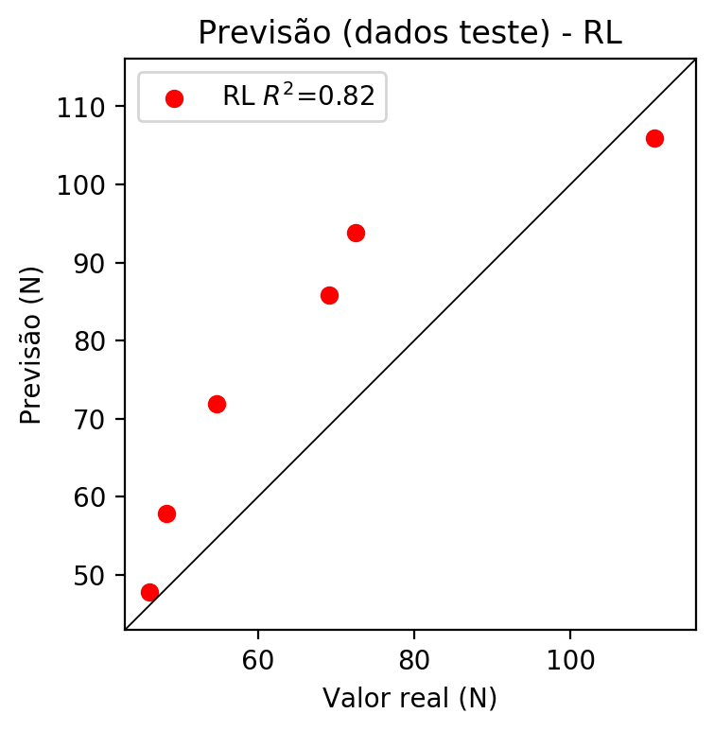

**Dados de treino**

* Erro relativo médio: 15.16
* Coeficiente de correlação: 0.88
* Coeficiente de determinação: 0.77
* MSE: 136.51
* RMSE: 11.68

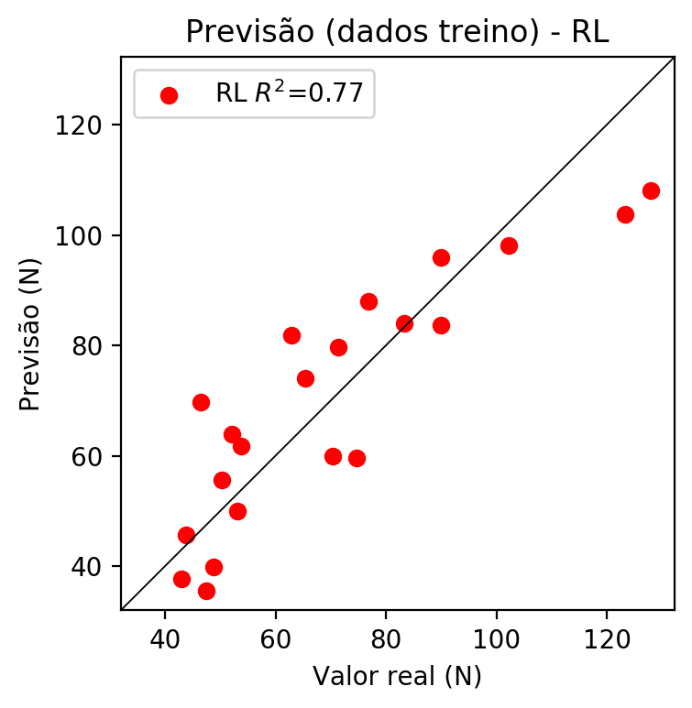

# RP2

# Coeficientes

[ 0. -0.06280069 0.35519703 0.87080722 0.25954814 -0.16759322  
 0.08545266 0.21982974 0.21412419 0.35481982]

# Erros

**Dados de teste**

* Erro relativo médio: 13.28
* Coeficiente de correlação: 0.93
* Coeficiente de determinação: 0.86
* MSE: 152.07
* RMSE: 12.33

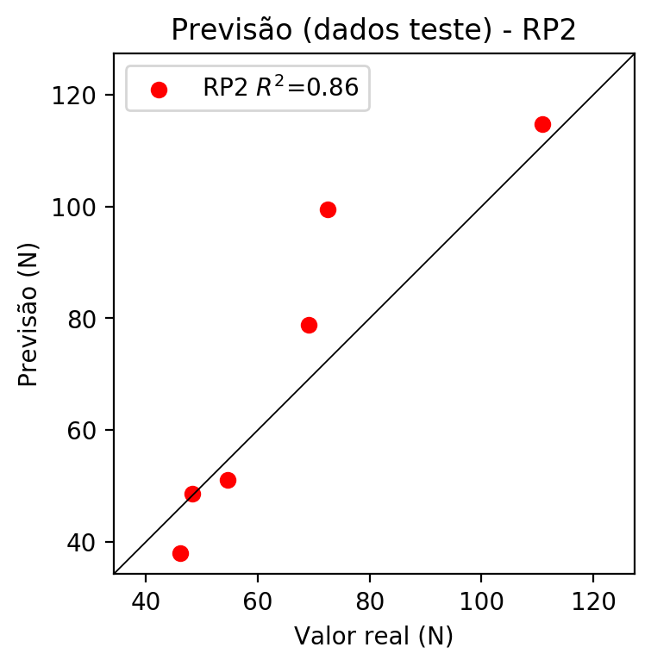

**Dados de treino**

* Erro relativo médio: 6.08
* Coeficiente de correlação: 0.98
* Coeficiente de determinação: 0.96
* MSE: 25.97
* RMSE: 5.1

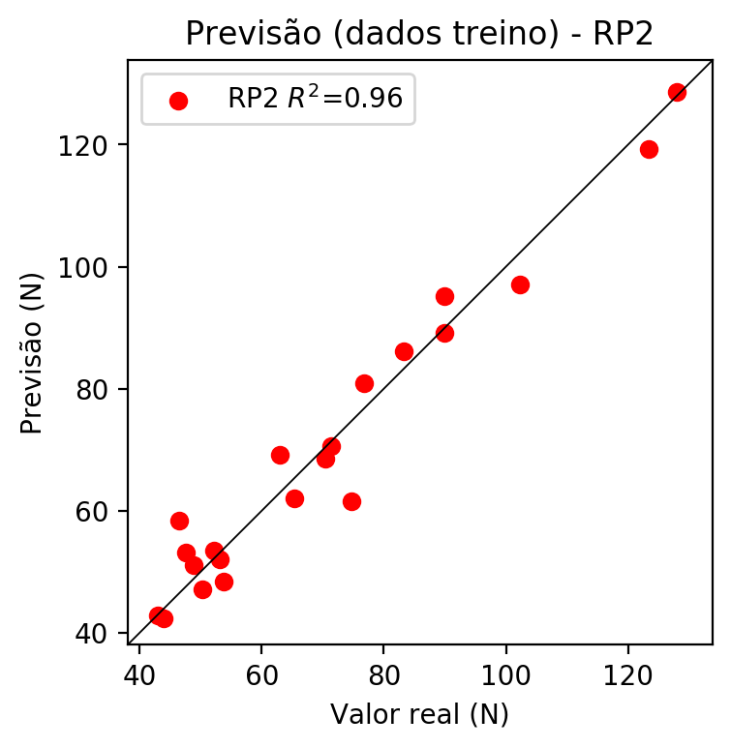

# RP3

# Coeficientes

[ 0. -0.0627079 0.04387847 0.29117819 0.24764449 -0.16759322  
 0.0644472 0.25953493 0.21768483 0.34324138 -0.09057808 0.07721133  
 -0.05017339 0.15228114 0.00321753 -0.03398797 0.06338002 0.01807668  
 0.14747976 0.42059072]

# Erros

**Dados de teste**

* Erro relativo médio: 13.2
* Coeficiente de correlação: 0.96
* Coeficiente de determinação: 0.92
* MSE: 102.47
* RMSE: 10.12

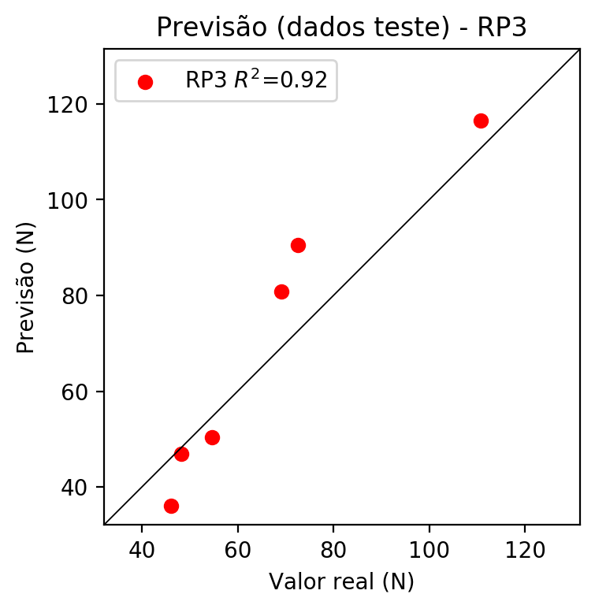

**Dados de treino**

* Erro relativo médio: 4.22
* Coeficiente de correlação: 0.99
* Coeficiente de determinação: 0.98
* MSE: 10.27
* RMSE: 3.2

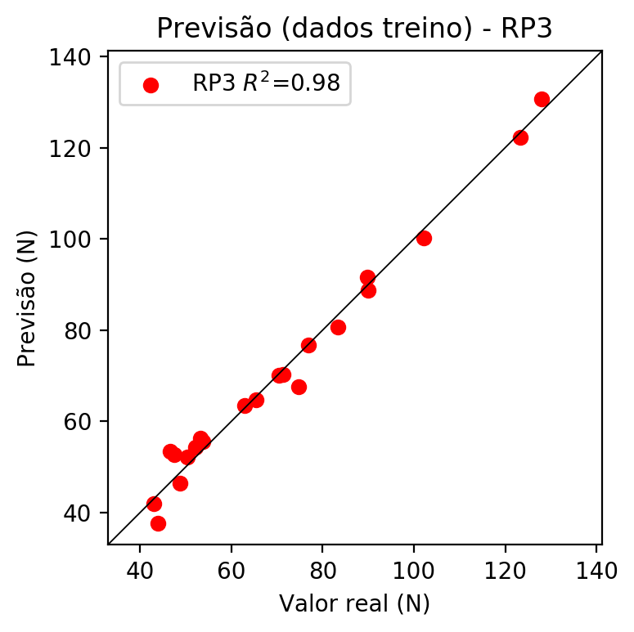

# RP4

# Coeficientes

[-0.00131576 -0.10606925 0.05008328 0.17843799 -0.03063523 -0.0463137  
 -0.04857502 0.0017915 0.02941277 0.13888105 -0.14901981 0.0572071  
 -0.01431643 0.28497282 0.00321753 -0.10033381 0.07242053 0.22711631  
 0.15748187 0.25707907 -0.0332777 -0.06939449 -0.0723136 0.29012476  
 0.03776452 -0.13750658 -0.06796383 0.25052201 0.08009336 -0.071658  
 -0.00788218 0.04464564 0.01822425 0.04515795 0.20053788]

# Erros

**Dados de teste**

* Erro relativo médio: 15.42
* Coeficiente de correlação: 0.91
* Coeficiente de determinação: 0.82
* MSE: 111.78
* RMSE: 10.57

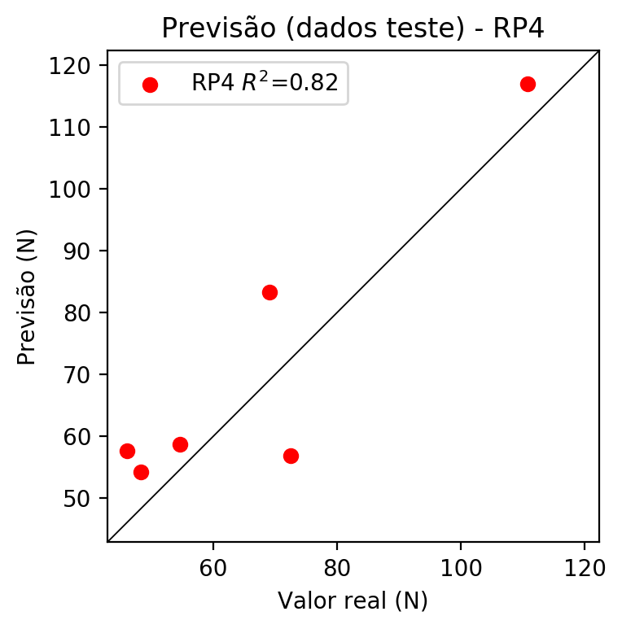

**Dados de treino**

* Erro relativo médio: 0.0
* Coeficiente de correlação: 1.0
* Coeficiente de determinação: 1.0
* MSE: 0.0
* RMSE: 0.0

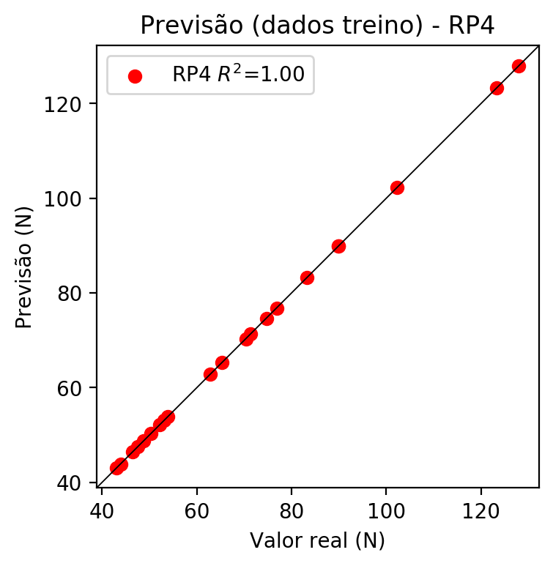

# Geral

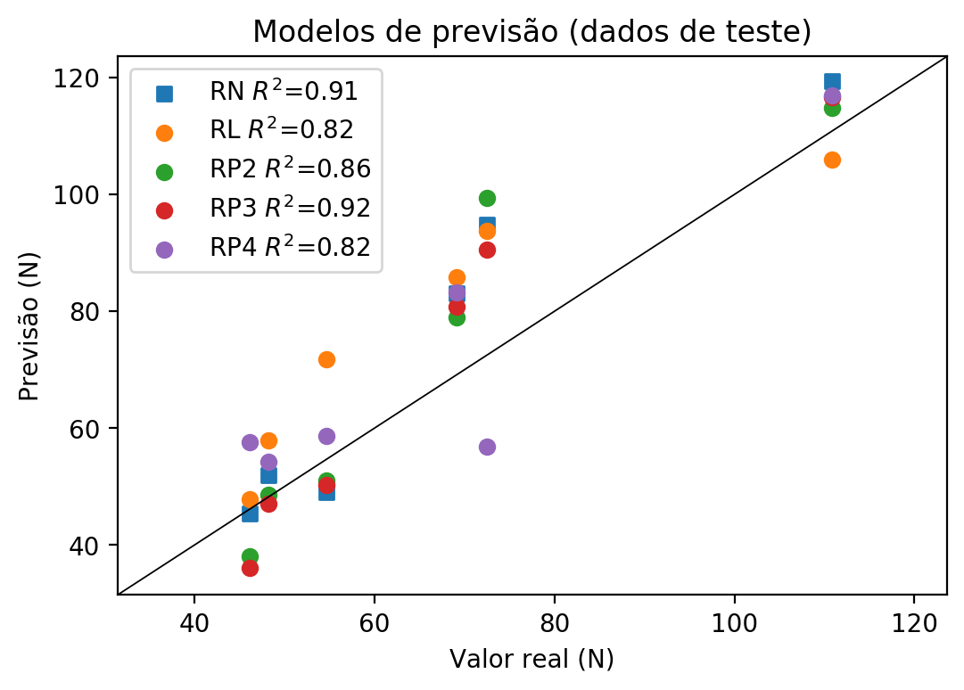

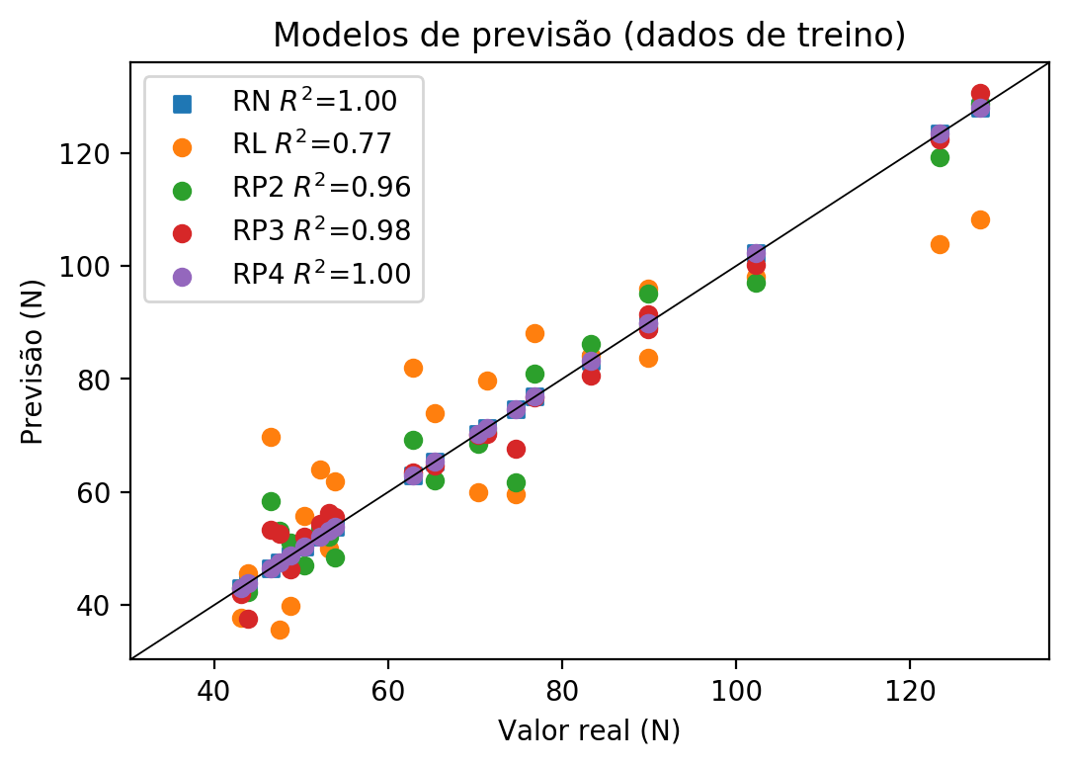

**Dados de teste**

|  |  |  |  |  |  |  |  |  |  |  |
| --- | --- | --- | --- | --- | --- | --- | --- | --- | --- | --- |
| Valor real | RN Previsto | RN Erro (%) | RL Previsto | RL Erro (%) | RP2 Previsto | RP2 Erro (%) | RP3 Previsto | RP3 Erro (%) | RP4 Previsto | RP4 Erro (%) |
| 46.11 | 45.38 | 1.58 | 47.8 | 3.67 | 38.05 | 17.48 | 36.09 | 21.73 | 57.68 | 25.09 |
| 110.81 | 119.4 | 7.75 | 105.97 | 4.37 | 114.81 | 3.61 | 116.58 | 5.21 | 116.93 | 5.52 |
| 69.13 | 83.08 | 20.18 | 85.88 | 24.23 | 78.89 | 14.12 | 80.81 | 16.9 | 83.31 | 20.51 |
| 72.53 | 94.88 | 30.81 | 93.77 | 29.28 | 99.42 | 37.07 | 90.54 | 24.83 | 56.83 | 21.65 |
| 48.27 | 52.04 | 7.81 | 57.85 | 19.85 | 48.66 | 0.81 | 47.01 | 2.61 | 54.24 | 12.37 |
| 54.67 | 49.0 | 10.37 | 71.86 | 31.44 | 51.07 | 6.58 | 50.34 | 7.92 | 58.69 | 7.35 |

**Dados de treino**

|  |  |  |  |  |  |  |  |  |  |  |
| --- | --- | --- | --- | --- | --- | --- | --- | --- | --- | --- |
| Valor real | RN Previsto | RN Erro (%) | RL Previsto | RL Erro (%) | RP2 Previsto | RP2 Erro (%) | RP3 Previsto | RP3 Erro (%) | RP4 Previsto | RP4 Erro (%) |
| 102.24 | 102.24 | 0.0 | 98.08 | 4.07 | 97.08 | 5.05 | 100.22 | 1.98 | 102.24 | 0.0 |
| 65.34 | 65.34 | 0.0 | 74.02 | 13.28 | 62.06 | 5.02 | 64.74 | 0.92 | 65.34 | 0.0 |
| 76.83 | 76.83 | 0.0 | 88.03 | 14.58 | 80.96 | 5.38 | 76.76 | 0.09 | 76.83 | 0.0 |
| 83.28 | 83.28 | 0.0 | 84.06 | 0.94 | 86.12 | 3.41 | 80.58 | 3.24 | 83.28 | 0.0 |
| 71.33 | 71.33 | 0.0 | 79.75 | 11.8 | 70.63 | 0.98 | 70.32 | 1.42 | 71.33 | 0.0 |
| 43.88 | 43.88 | 0.0 | 45.65 | 4.03 | 42.34 | 3.51 | 37.55 | 14.43 | 43.88 | 0.0 |
| 53.82 | 53.82 | 0.0 | 61.82 | 14.86 | 48.41 | 10.05 | 55.51 | 3.14 | 53.82 | 0.0 |
| 127.96 | 127.96 | 0.0 | 108.12 | 15.5 | 128.69 | 0.57 | 130.61 | 2.07 | 127.96 | 0.0 |
| 123.36 | 123.36 | 0.0 | 103.81 | 15.85 | 119.22 | 3.36 | 122.28 | 0.88 | 123.36 | 0.0 |
| 52.12 | 52.12 | 0.0 | 63.97 | 22.74 | 53.49 | 2.63 | 54.29 | 4.16 | 52.12 | 0.0 |
| 48.78 | 48.78 | 0.0 | 39.91 | 18.18 | 51.02 | 4.59 | 46.4 | 4.88 | 48.78 | 0.0 |
| 47.52 | 47.52 | 0.0 | 35.6 | 25.08 | 53.12 | 11.78 | 52.61 | 10.71 | 47.52 | 0.0 |
| 74.66 | 74.66 | 0.0 | 59.66 | 20.09 | 61.62 | 17.47 | 67.65 | 9.39 | 74.66 | 0.0 |
| 53.14 | 53.14 | 0.0 | 49.96 | 5.98 | 52.04 | 2.07 | 56.32 | 5.98 | 53.14 | 0.0 |
| 50.35 | 50.35 | 0.0 | 55.69 | 10.61 | 47.05 | 6.55 | 52.15 | 3.57 | 50.35 | 0.0 |
| 89.91 | 89.91 | 0.0 | 95.92 | 6.68 | 89.11 | 0.89 | 88.78 | 1.26 | 89.91 | 0.0 |
| 46.5 | 46.5 | 0.0 | 69.71 | 49.91 | 58.38 | 25.55 | 53.39 | 14.82 | 46.5 | 0.0 |
| 43.05 | 43.05 | 0.0 | 37.76 | 12.29 | 42.92 | 0.3 | 41.92 | 2.62 | 43.05 | 0.0 |
| 89.87 | 89.87 | 0.0 | 83.72 | 6.84 | 95.11 | 5.83 | 91.51 | 1.82 | 89.87 | 0.0 |
| 70.34 | 70.34 | 0.0 | 60.0 | 14.7 | 68.56 | 2.53 | 70.11 | 0.33 | 70.34 | 0.0 |
| 62.89 | 62.89 | 0.0 | 81.91 | 30.24 | 69.23 | 10.08 | 63.45 | 0.89 | 62.89 | 0.0 |